INDEPENDENT CHAIR, Barking Riverside Community Interest Company (CIC) Review Process
Please note, Barking Riverside is committed to communicating in plain English and so we are working on using less industry-specific language in our documentation. This is so we can share information with community members in a way that is transparent, clear and simple to use.
Introduction to the role
Barking Riverside London is looking to appoint an inspirational Independent Chair to lead a “Learning Forum” of residents, senior political stakeholders, community group representatives and consultants. This role could be filled by an individual who operates as a consultant, or by an organisation who takes responsibility for leading the Learning Forum.
This Learning Forum is being created so that decisions about the long-term custodianship of Barking Riverside, one of Europe’s largest mixed-use estates, can be made jointly with local people. This is a very different way of making decisions, and so the Independent Chair role should be attractive to individuals or organisations that are passionate about community leadership, as well as the property industry becoming a more innovative and forward-thinking environment.
Barking Riverside is a development of 10,800 homes on the bank of the River Thames in East London. It has an established community that is growing, meaning that over the course of the next 10 years the population at Barking Riverside will eventually become the size of a small town. Barking Riverside has plans to transfer all public spaces and buildings into a Community Interest Company (CIC), and so the aim is for local people and stakeholders to undertake a review of the current structure to consider if changes are needed. The Learning Forum will complete this review and will make recommendations on whether the CIC can be improved for the benefit of the community.
To lead this review process, Barking Riverside is inviting applications for a bold and exceptional candidate, who understands community perspectives, to chair this exciting piece of learning. The overall objective of this work is to conclude the Learning Forum process with a future governance model for the estate that those in the Learning Forum passionately endorse.
We attach some previous information that we prepared for a resident information evening on the CIC. We hope this is useful in explaining the role more fully and providing more context.

What expertise, knowledge and experience do we think the Independent Chair should have?
Because the review process is ambitious, we know a wide variety of expertise, knowledge and experience is needed for the Independent Chair to be successful. Whilst we may find all the qualities in one individual, we think it is more likely that we would work with a lead organisation or person who is then responsible for appointing other consultancy support to fulfil all the criteria below. BRL can also provide support in scoping additional support with the successful candidate.
We believe that the purpose of the Independent Chair, and the skill set that we think they should bring, must be clear and understandable to all stakeholders. So, we have prepared a simple diagram that explains exactly what expertise, knowledge and experience we will be looking for in the Independent Chair. This diagram has been tested and refined with local community members.

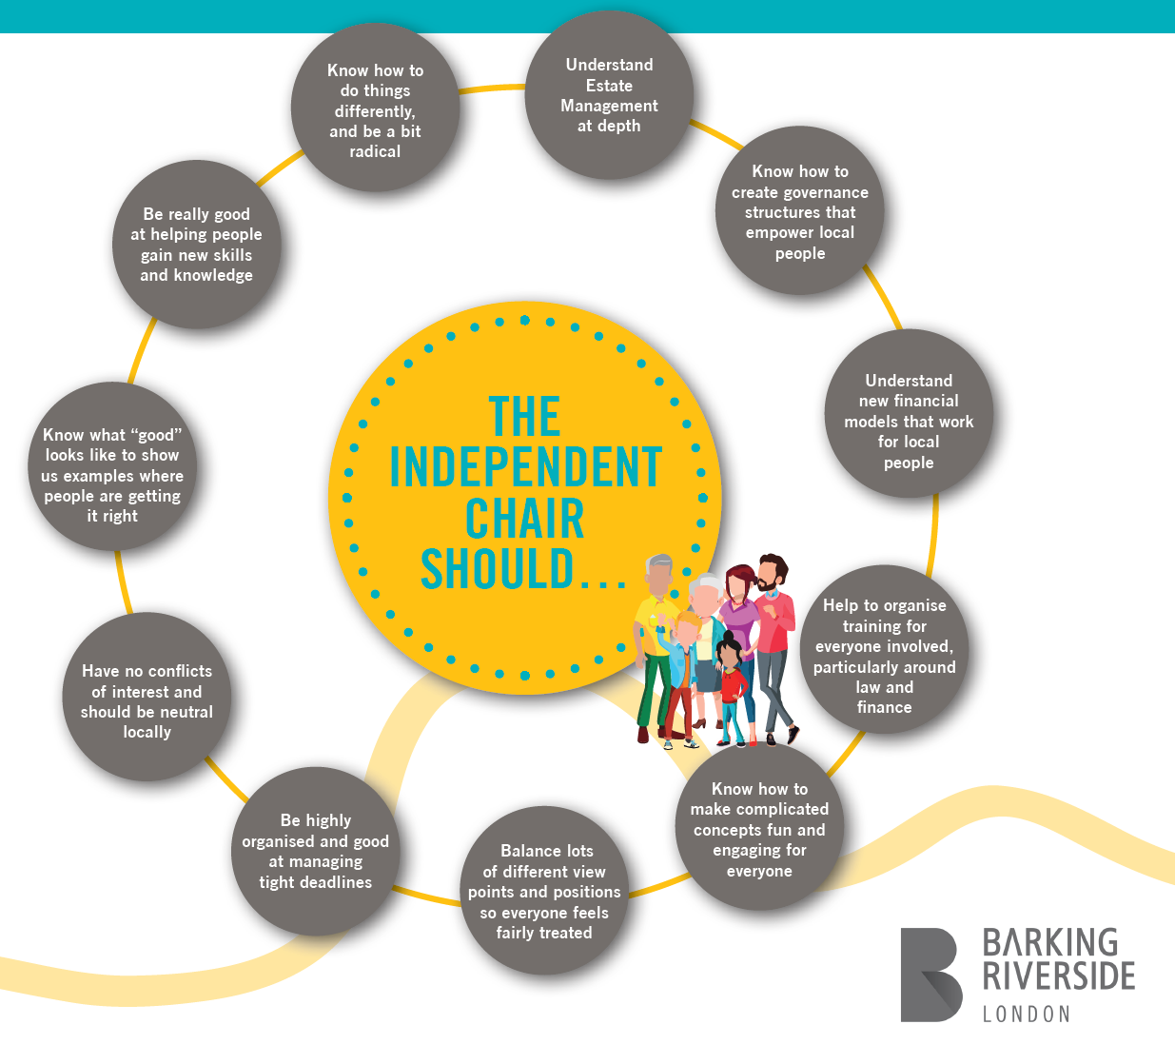Please see more detail below on each of these areas:
- Know how to create governance structures that empower local people – there is a need for the Chair to have a strong understanding of “bottom-up” governance structures that empower residents to take greater control and ownership, whilst still working in partnership with other stakeholders. (E)

- Know how to make complicated concepts fun and engaging for everyone – the individual or organisation should be able to make the Learning Forum sessions fun and engaging for all those who attend. They need to have experience of explaining complicated ideas or processes in a way that still makes the information interesting for residents and all other stakeholders. (E)

- Balance lots of different viewpoints and positions so everyone feels fairly treated – we need a strong Chair who can keep pace and control, but who can also host sessions in a way where everyone is encouraged to participate. It is important that they can listen to all the voices in the room and understand that some people will feel less confident to challenge and interact. (E)

- Understand new financial models that work for local people – information and advice is needed on brave new ways of structuring businesses. We want the CIC to be both a successful economic model and a way of bringing about community benefit for residents. (E)

- Help to organise training for everyone involved, particularly around law or finance – the individual or organisation would need to understand the legal and financial responsibilities involved in governing something like a CIC and should be able to scope a good quality training plan for those who are part of the Learning Forum. (D)

- They should know how to work with very different types of group – they should have experience of advising big businesses, public bodies such as the Council, and also smaller community-run groups, like local charities. It is important that all view points and perspectives can be given equal weight. (D)

- Be highly organised and good at managing tight deadlines – the individual or organisation needs to be able to run both the Learning Forum and the CIC review process smoothly on behalf of all the stakeholders. With multiple meetings to facilitate, and lots of material to be provided, there needs to be a strong sense of structure and organisation to lead everyone within the time constraint. (D)

- Understand estate and facilities management at depth – they should have previous experience of advising businesses on their estate and facilities management. They must have a knowledge of service charge and should understand the associated rules and regulations. Experience of health and safety and compliance is also useful. (D)

- Have no “conflicts of interest” and be neutral locally – the individual or organisation should not have worked particularly closely with any of the involved stakeholders before so that a free and fresh perspective on the CIC can be taken. There needs to be no current conflicts of interest. Evidence of being politically neutral is also important. (E)

- Know what “good” looks like to show us examples of where people are getting it right – we want those in the Learning Forum to be able visit other places or people who have some experience with Community Interest Companies and who have an interesting story to tell. Therefore, it is important that the Independent Chair is well connected in the industry and understands where there are good examples. (E)

- Be really good at helping people gain new skills and knowledge – the individual or organisation must be able to help those who join the Learning Forum gain new knowledge. The individual or organisation should regularly check that all Learning Forum members are getting what they want from the process and that they feel they are being “up-skilled” by being involved. (D)

- Know how to do things a bit differently and be a bit radical – we are all keen to break the mould and do something that is brave. We want to re-imagine how stakeholders make local decisions. This means we need to work with an individual or organisation who will bring flair, imagination and a sense of being radical to the Learning Forum. We want to work with someone who knows how to inspire change in an exciting way, but who also understands all the practical, legal and financial considerations. (E)
There are lots of “unknowns” in relation to the CIC review because it is so different and so ground-breaking, so rather than providing an exact time commitment we instead want to work with the best candidate to scope how much time the process should take. However, we do the think the individual or organisation needs to be available for at least one or two days a week for a period of 9 months.
What would the Independent Chair be responsible for, and what are the outcomes that we are expecting?
The individual or organisation leading the Learning Forum needs to be both a specialist who can provide advice on specific areas, like governance, but they also need to be prepared to lead the Learning Forum from a project management perspective to make sure the entire CIC review process is independent of Barking Riverside and the current CIC Board. We appreciated this is a broad range of duties, so it may be that once the Chair is appointed, they find additional support from other specialists so that the following can be achieved. Even if external specialists are used, the Independent Chair would still be responsible for the following items and outcomes.
- Appointing residents to join the Learning Forum – Barking Riverside have received interest from several residents who want to join the Learning Forum. However, the Chair will ultimately decide on how many residents or community group representatives join the Learning Forum, and how other stakeholders are involved in the process.
- Road mapping the CIC review journey for Learning Forum members – the Independent Chair should work with the Learning Forum to assess what they want to achieve, and then create and plan or road map that shows everyone how we will all get there. This will scope the time commitment that everyone needs to give, what areas of learning can be delivered by the Independent Chair and those areas that need to be delivered by other specialists.
- Diarising and chairing the Learning Forum – the Independent Chair would be responsible for organising when and how the Learning Forum members should meet. They will also chair all Learning Forum sessions in a way where the group is kept on track during the meetings and workshops. They will also diarise any visits or training that is identified and arrange for these to be delivered within the schedule. The Chair may also need to meet with individual stakeholders outside of the group Learning Forum sessions if required.
- Creating materials for the Learning Forum – this may include agendas, minutes, action trackers, reports and any other information that is needed to keep Learning Forum members, as well as external stakeholders, informed of progress and decisions. The Chair will also need to create learning material to use in the sessions to explain concepts or recommendations back to the Learning Forum.
- Resolving any conflict – If any conflicts or impasses arise within the Learning Forum that prevent major decisions being made, the Independent Chair should act as the arbitrator and find a resolution so that the CIC review process can continue.
- Making sure the CIC process is understood publicly – so that more local people can be aware of the work that the Learning Forum is undertaking, work with partners to make sure process is being communicated. This will also involve advising the Learning Forum on when they should be testing their emerging thoughts on the CIC model with a wider local audience by hosting public engagement opportunities. The Chair should also help organise these engagement opportunities and work with the Learning Forum to analyse and incorporate any recommendation or suggestions.
- Structured decision making – once the CIC review process has been completed, the Independent Chair should bring together their recommendations on the CIC model for Learning Forum members. They should then create and facilitate a sign-off or decision-making process so that Learning Forum members can endorse a final model.
- Making a record of the process, including an in-depth description and analysis of the final model that has been endorsed by the Learning Forum – this should explain what the CIC review process included, and how decision making was made. This final record should also suggest next steps so that when the Independent Chair steps away, local people and other stakeholders understand how they can make the recommendations a reality.
Applications
Applications for this position will open on the 9th of September – you will have three weeks to apply, meaning that all applications need to be returned by midnight on the 30th of September. Please apply using your CV and a covering letter explaining how you, or your organisation, fulfils experience, expertise and knowledge that we have said is needed for this role, as well as your approach to structuring the Learning Forum. Please send the CV and covering letter to cicprocess@barkingriversideltd.org

